DOCUMENT 14 — ASK App Specification
Visionary Internal · v1.0 · The human conversation moment (4-app framework: ASK)

ASK is not a search engine. It is a conversation with a teacher who already knows you.
The context chip appears before the user types.

1. Surface contract
- Composer label: "Ask me anything, Ecoh…" (Fix 01 — search bar removed).
- Context chip: "5 subjects · 32 topics" style — memory made visible pre-input.
- Suggested questions rotate from actual recent activity (real topic names, never generic).
- Voice input (Hindi-first ASR); photo-of-problem entry deferred to Phase 2.
- After every session: confidence scores update for discussed topics (SCM write).

2. Request path
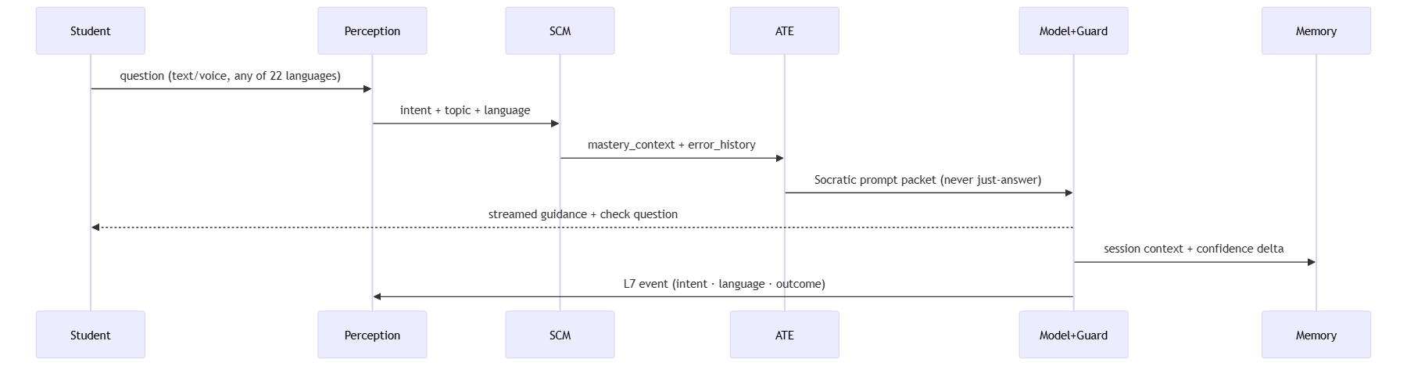

3. Behavior rules (Doc 01 §06 carried forward)
Speak specifically never generally · reference something real about the user before any
general answer · guide to the answer (Socratic) · 3 wrong in a row → switch explanation
style · >5 min stuck → break into smaller pieces · short session → single most important
thing · return after 5 days → brief memory refresh first.

4. States
Empty/new: context chip + 3 personalized suggestions (no fabricated history) ·
Error: inline retry, draft preserved · Offline: queue with "Saved on this device," no
cloud-sync claim · Storage failure: "Couldn't save on this device" + Retry, never show Saved.

OKF
KF1 TTFT ≤200ms p95 · KF2 100% of turns emit L7 event · KF3 ≥1 suggested question references
a recent topic · KF4 draft survives refresh/history-switch/workspace-return · KF5 existing
conversations open without forced onboarding.

